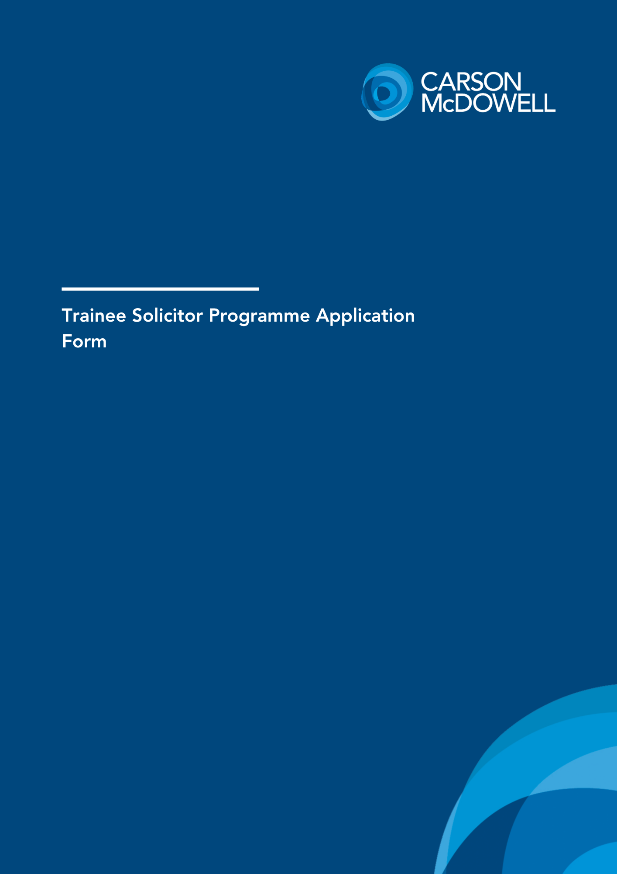

Carson McDowell is Northern Ireland’s largest commercial law firm. We have more lawyers recognised as leaders in their area (and externally accredited as such) than any other law firm in Northern Ireland. We pride ourselves on attracting and employing driven people who will help us to achieve even greater success. This application form has been designed to provide you with the opportunity to tell us why you are the right candidate for a training contract with Carson McDowell.
What are we looking for?
Tell us what makes you stand out from the crowd, and why you think Carson McDowell is the right firm for you.
We want:
- All-rounders who are commercially aware
- Motivated, high achievers
- Good attention to detail
- Problem-solvers and lateral thinks
- Good communicators and team players
Tips and Tricks:
- This is your chance to set yourself apart from other candidates.
- Opt for quality over quantity- make every word count.
- Give yourself plenty of time to complete the form. - a second pair of eyes can't hurt!
Take this opportunity to show us why you are keen to pursue a career in law and just as importantly, why with Carson McDowell?
Note for candidates:
Applicants must use this form to apply for a training contact with the firm. CVs are not accepted.
Please complete each section of this application form.
Your completed form should be returned by email to recruitment@carson-mcdowell.com by 5.00pm on Friday 9th October 2026. Your application should be signed, and named ‘First name, Surname, Trainee Application’.
If you are shortlisted for interview, we will be in touch with you in due course to arrange for an interview.
We wish you the best of luck in your application.

Section 1: Contact Details
Name:
Email:
Phone Number:
Tell us about yourself (200 words max):

Section 2: Academic Record and Education
Secondary Education Examinations/results:

Examination | Year | Subject | Grade
GCSE
A/S Level
A2 Level
Other (if applicable) (e.g. Leaving Certificate)

Details of law degree:

University:

Name of degree course:

Date of commencement of study:
Date of graduation (actual/predicted):

Degree classification (if known):

Examinations/results

Subject/Module | Year of course |  | Mark

Section 3: Work Experience
Please provide details of any relevant work experience, placements, or summer jobs. We have provided space for up to 2 examples- only complete what is relevant (if you only have 1, that's fine). This is your opportunity to present what you have learned or developed in your experience to date.
Work experience example 1

Employer:

Type of business:

Commencement date:

End date:

Employment or other?

Please set out a brief description of your main activities and responsibilities in this role, including any achievements or elements that you feel are relevant to your application for a training contract with Carson McDowell

Work experience example 2

Employer:

Type of business:

Commencement date:

End date:

Employment or other?

Please set out a brief description of your main activities and responsibilities in this role, including any achievements or elements that you feel are relevant to your application for a training contract with Carson McDowell

Section 4: Candidate Answers
Please answer the following questions, providing answers no longer than 300 words each.
Question 1: What attracts you to Carson McDowell?
Question 2: What area of law currently interests you most and why?
Question 3: Tell us about a challenge you have faced in work, education, or personal life, and what you have learned from it.
Question 4: If you are successful, what quality would you most like to see in your trainee solicitor cohort and why?

Section 5: Confirmation

I understand that Carson McDowell will be relying on the responses and information that I have provided on this application form being accurate, true, complete and not misleading. I can confirm that I have reviewed the contents of this application form carefully before submission and that I am able to confirm that all of the responses and information that I have provided on this application form are accurate, true, complete and not misleading.
I understand and acknowledge that if any of the responses and information is not, or subsequently ceases to be, accurate, true, complete or not misleading, Carson McDowell shall be entitled to revoke or withdraw any offer of an interview with the firm or, as the case may be, any offer of a training contract with the firm.
I understand that I may be required by Carson McDowell to provide further information or clarification in relation to any of the responses and information that I have provided on this application form. This may include the production of original correspondence, certificates or documentary evidence. I understand that the Carson McDowell will record, store and process personal data in relation to relevant aspects of my application for a training contract.
I understand that Carson McDowell shall not be under any obligation to offer me an interview for a training contract or to offer me a training contract.
We accept digital signatures
Signature |  | Date

